How to find books within a Lexile Range
Log onto a school computer
Click on the Destiny Media – Kennedy Jr. icon in the Launchpad
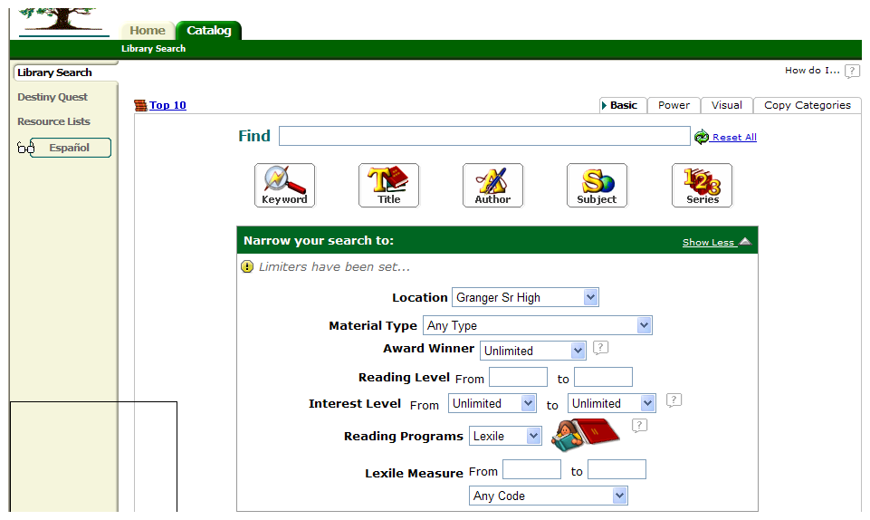
Click on the Catalog tab
Under Reading Programs click Lexile
Enter the Lexile range given on the SRI test
Click the Keyword button – You do not need to put anything in the Find line.
Destiny will give the student several pages of books that fall in the range given.
If you want to narrow your search by subject, you can enter the subject in the Find box.

Lexile Score Background Information
A student’s Lexile range spans from 50L above to 100L below his or her Lexile measure. Books in this Lexile range are well-targeted to the student’s reading ability, focused around a forecasted 75% comprehension rate when the reader and book have the same Lexile measure. While reading a book in his or her Lexile range, the student will encounter new sentence structures and vocabulary—which fosters reading growth—while still being able to understand the overall text. Lexile measures help teachers and parents to know what a specific reading experience will be like for a specific student, so that they can provide the appropriate instructional support.
Of course, a student can still read outside of his or her Lexile range . When a student is highly motivated to read a book above his or her Lexile range , teachers and parents will know that additional scaffolding and support will likely be necessary. Still, this is a wonderful opportunity for reading and vocabulary growth. With books below a student’s Lexile range, struggling or reluctant readers can build confidence, fluency and skill. Teachers and parents can help the student understand challenging subject matter by finding lower-Lexile reading materials on that specific topic.

- Michelle Asay, modified by Angie Christensen

